**Question 1:** Read and print the pixel values of an image

**Code:**

#include <opencv2/opencv.hpp>

#include <iostream>

#include <string>

int main()

{

std::string filename;

std::cin >> filename;

cv::Mat img = cv::imread(filename);

int rows = img.rows, cols = img.cols * img.channels();

std::cout << img.rows << '*' << img.cols << " Channels: " << img.channels() << '\n';

const uchar* ptr;

if(img.isContinuous())

{

cols *= rows; rows = 1;

}

for(int i = 0; i < rows; i++)

{

ptr = img.ptr<uchar>(i);

for(int j = 0; j < cols; j++)

std::cout << (int)ptr[j] << ' ';

std::cout << '\n';

}

}

**Output:**



**Question 2: Print histogram of pixel values of a grey image**

**Code:**

#include <opencv2/opencv.hpp>

#include <iostream>

#include <vector>

#include <array>

int main()

{

cv::Mat src = cv::imread("/home/rohan/Downloads/OpenCVWorkshop2019/images/sharpening.png");

std::vector<cv::Mat> bgr_planes;

cv::split(src, bgr_planes);

int histSize = 256;

std::array<float, 2> range = {0, 256};

const float* histRange = {range.data()};

cv::Mat b_hist, g_hist, r_hist;

cv::calcHist(&bgr_planes[0], 1, 0, cv::Mat(), b_hist, 1, &histSize, &histRange);

cv::calcHist(&bgr_planes[1], 1, 0, cv::Mat(), g_hist, 1, &histSize, &histRange);

cv::calcHist(&bgr_planes[2], 1, 0, cv::Mat(), r_hist, 1, &histSize, &histRange);

int hist_w = 512, hist_h = 400;

int bin_w = cvRound((double)hist_w / histSize);

cv::Mat histImage(hist_h, hist_w, CV_8UC3, cv::Scalar(0, 0, 0));

cv::normalize(b_hist, b_hist, 0, histImage.rows, cv::NORM_MINMAX, -1, cv::Mat());

cv::normalize(g_hist, g_hist, 0, histImage.rows, cv::NORM_MINMAX, -1, cv::Mat());

cv::normalize(r_hist, r_hist, 0, histImage.rows, cv::NORM_MINMAX, -1, cv::Mat());

for(int i = 1; i < histSize; i++)

{

cv::line(histImage, cv::Point(bin_w * (i - 1), hist_h - cvRound(b_hist.at<float>(i - 1))),

cv::Point(bin_w * (i), hist_h - cvRound(b_hist.at<float>(i))), cv::Scalar(255, 0, 0));

cv::line(histImage, cv::Point(bin_w * (i - 1), hist_h - cvRound(g_hist.at<float>(i - 1))),

cv::Point(bin_w * (i), hist_h - cvRound(g_hist.at<float>(i))), cv::Scalar(0, 255, 0));

cv::line(histImage, cv::Point(bin_w * (i - 1), hist_h - cvRound(r_hist.at<float>(i - 1))),

cv::Point(bin_w * (i), hist_h - cvRound(r_hist.at<float>(i))), cv::Scalar(0, 0, 255));

}

cv::imshow("Source Image", src);

cv::imshow("calcHist Demo", histImage);

cv::waitKey();

}

**Output:**

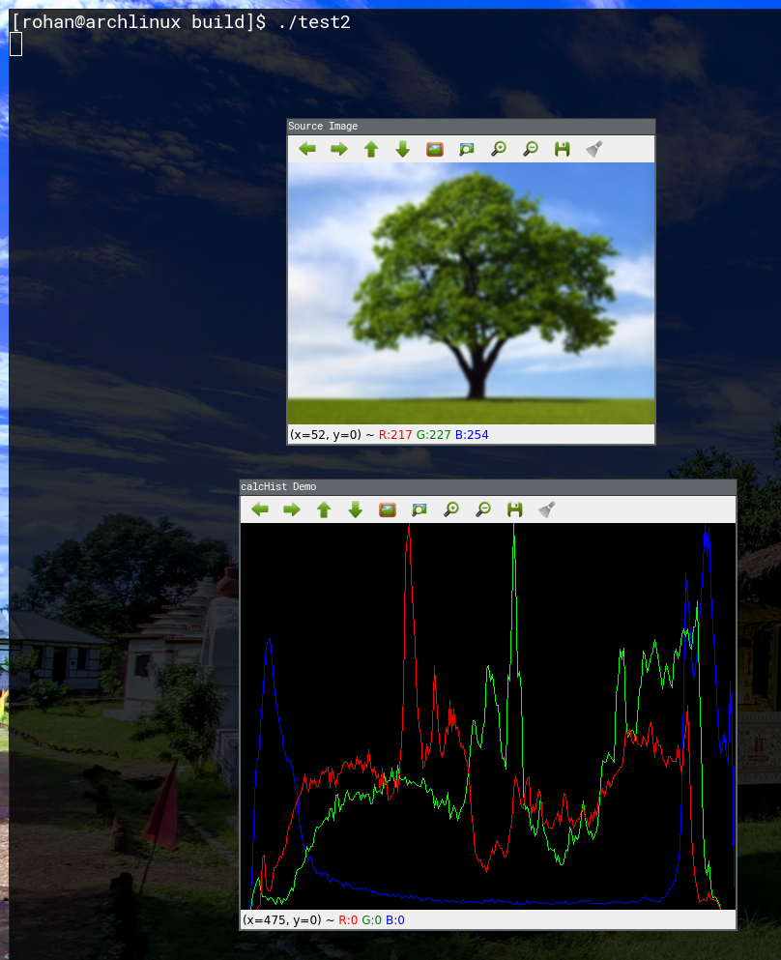

**Question 3:** Display inverted gray image

**Code:**

#include <iostream>

#include <string>

#include <opencv2/opencv.hpp>

int main()

{

std::string filename; std::cin >> filename;

cv::Mat img = cv::imread(filename), img_gray;

cv::imshow("original", img);

cv::cvtColor(img, img_gray, cv::COLOR_BGR2GRAY);

cv::imshow("Gray", img_gray);

cv::waitKey();

}

**Output:**

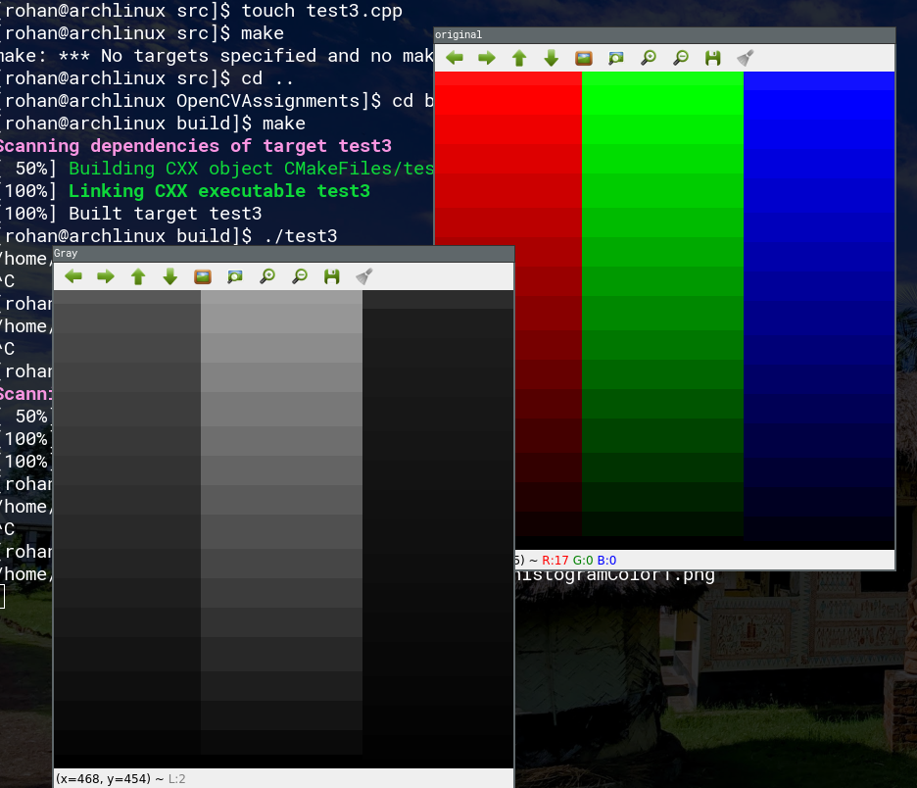

**Question 4:** Enhance overall brightness of a grey image by a given value.

**Code:**

#include <opencv2/opencv.hpp>

#include <iostream>

#include <string>

int main()

{

std::string filename; std::cin >> filename;

cv::Mat img = cv::imread(filename);

float beta; std::cin >> beta;

cv::imshow("Original", img);

cv::Mat lookupTable(1, 256, CV_8U);

uchar* p = lookupTable.ptr();

for(int i = 0; i < 256; i++)

p[i] = cv::saturate_cast<uchar>(i + beta);

cv::LUT(img, lookupTable, img);

cv::imshow("Altered Image", img);

cv::waitKey();

}

**Output:**

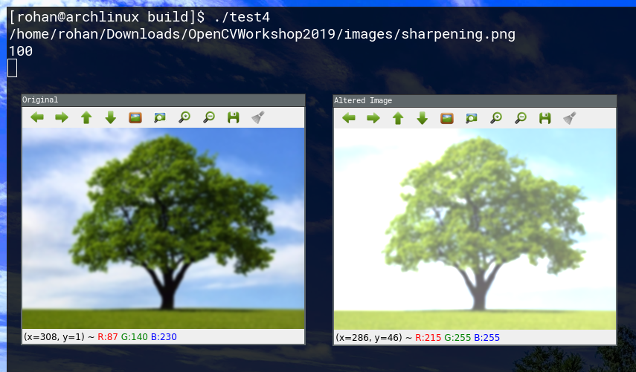

**Question 5:** Enhance contrast of a grey image.

**Code:**

#include <opencv2/opencv.hpp>

#include <iostream>

#include <string>

int main()

{

std::string filename; std::cin >> filename;

cv::Mat img = cv::imread(filename);

float alpha; std::cin >> alpha;

cv::imshow("Original", img);

cv::Mat lookupTable(1, 256, CV_8U);

uchar* p = lookupTable.ptr();

for(int i = 0; i < 256; i++)

p[i] = cv::saturate_cast<uchar>(i * alpha);

cv::LUT(img, lookupTable, img);

cv::imshow("Altered Image", img);

cv::waitKey();

}

**Output:**

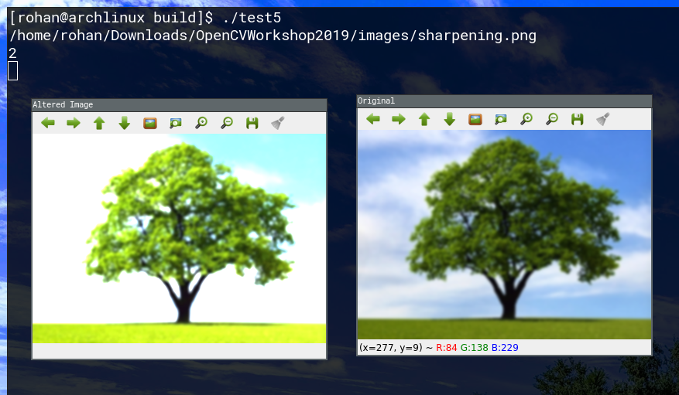

**Question 6:** Perform histogram equalization to enhance quality of a grey image.

**Code:**

#include <opencv2/opencv.hpp>

#include <iostream>

#include <string>

int main()

{

std::string filename; std::cin >> filename;

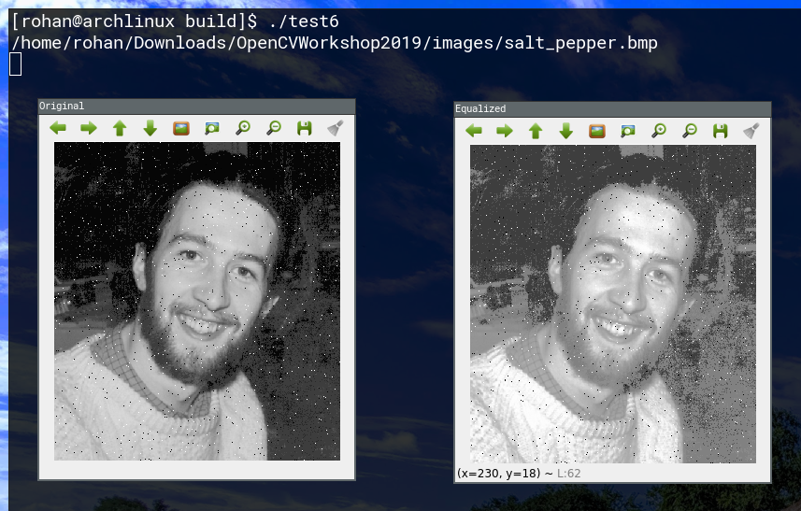 cv::Mat img = cv::imread(filename);

cv::cvtColor(img, img, cv::COLOR_BGR2GRAY);

cv::imshow("Original", img);

cv::Mat m_img;

cv::equalizeHist(img, m_img);

cv::imshow("Equalized", m_img);

cv::waitKey();

}

**Output:**

**Question 7:** Generate a binary thresholded image from a grey image.

**Code:**

#include <opencv2/opencv.hpp>

#include <iostream>

cv::Mat img, img1;

int threshVal = 127;

int maxThreshVal = 255;

void callback(int, void*)

{

cv::threshold(img, img1, threshVal, maxThreshVal, cv::ThresholdTypes::THRESH_BINARY);

cv::imshow("Thresholded", img1);

}

int main()

{

std::string filename; std::cin >> filename;

img = cv::imread(filename);

cv::cvtColor(img, img, cv::COLOR_BGR2GRAY);

cv::imshow("Original", img);

cv::namedWindow("Thresholded");

cv::createTrackbar("threshold", "Thresholded", &threshVal, maxThreshVal, callback);

callback(threshVal, 0);

cv::waitKey();

}

**Output:**

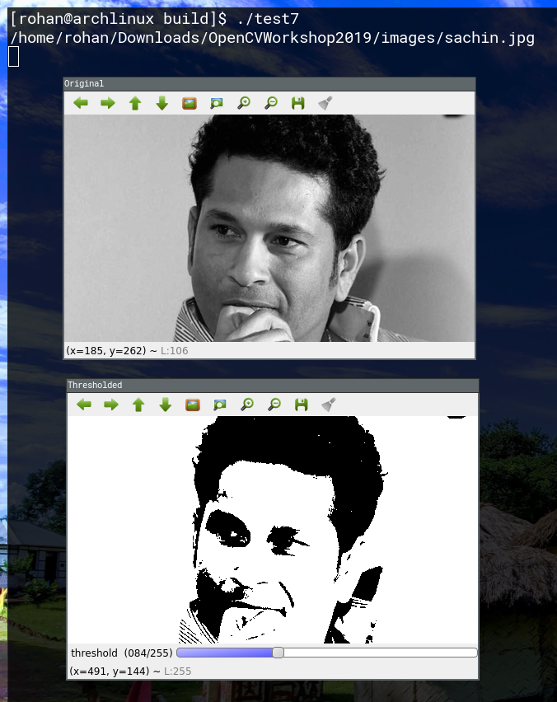

**Question 8:** Zoom in and zoom out a grey image by a given scale factor.

**Code:**

#include <opencv2/opencv.hpp>

#include <iostream>

cv::Mat img, img1;

int val = 5;

int maxVal = 10;

void callback(int, void*)

{

double factor = (double)val / (maxVal / 2);

cv::resize(img, img1, cv::Size(), factor, factor);

cv::imshow("zoomed", img1);

}

int main()

{

std::string filename; std::cin >> filename;

img = cv::imread(filename);

cv::imshow("original", img);

cv::namedWindow("zoomed");

cv::createTrackbar("scale", "zoomed", &val, maxVal, callback);

callback(val, 0);

cv::waitKey();

}

**Output:**

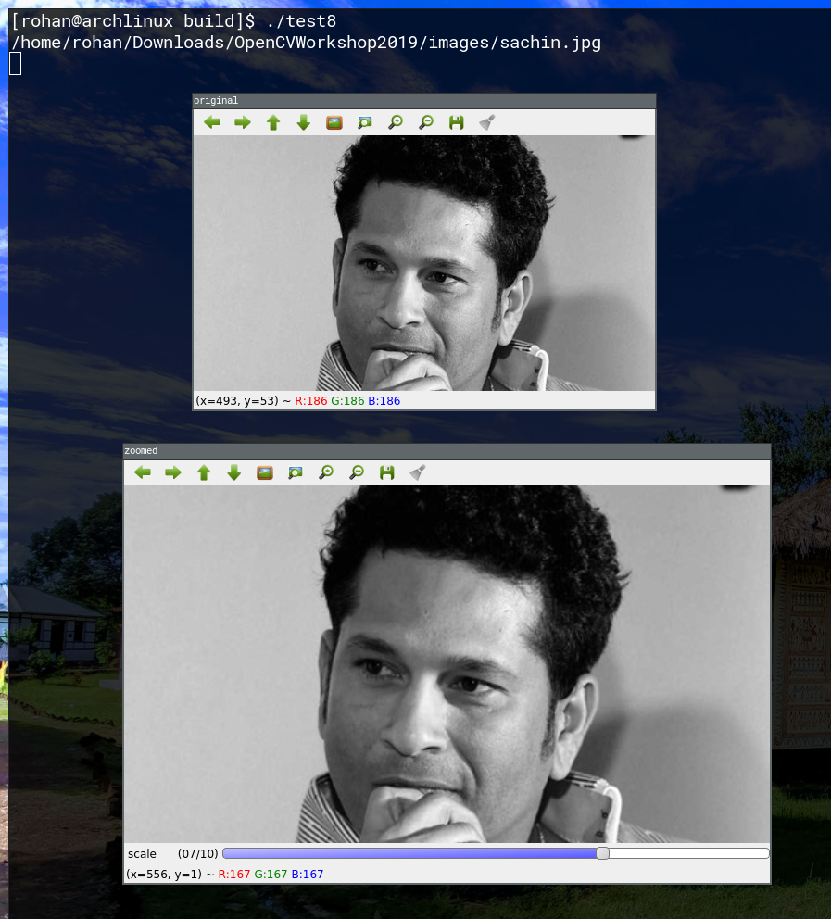

**Question 9:** Crop a rectangular area of a grey image and pad the cropped image given the location of the crop-window along with its dimensions and the pad-width.

**Code:**

#include <opencv2/opencv.hpp>

#include <iostream>

#include <string>

cv::Mat img, img1;

int clicks = 0;

cv::Point start, end;

void callback(int event, int x, int y, int flags, void* param)

{

if(clicks == 0)

{

if(event == cv::MouseEventTypes::EVENT_LBUTTONDOWN)

{

start = cv::Point(x, y);

clicks++;

}

}

else if(clicks == 1)

{

if(event == cv::MouseEventTypes::EVENT_MOUSEMOVE)

{

end = cv::Point(x, y);

img1 = img.clone();

cv::rectangle(img1, start, end, cv::Scalar(0, 0, 255));

cv::imshow("Original", img1);

}

else if(event == cv::MouseEventTypes::EVENT_LBUTTONDOWN)

{

clicks++;

end = cv::Point(x, y);

img1 = img.clone();

img1 = img1(cv::Rect(start, end));

int top = (int)(0.05 * img1.rows), left = (int)(0.05 * img1.cols), bot = top, right = left;

cv::copyMakeBorder(img1, img1, top, left, bot, right, cv::BORDER_ISOLATED, cv::Scalar(0, 0, 255));

cv::imshow("New", img1);

}

}

cv::waitKey(1);

}

int main()

{

std::string filename; std::cin >> filename;

img = cv::imread(filename);

cv::namedWindow("Original");

cv::imshow("Original", img);

cv::setMouseCallback("Original", callback, nullptr);

cv::waitKey();

}

**Output:**

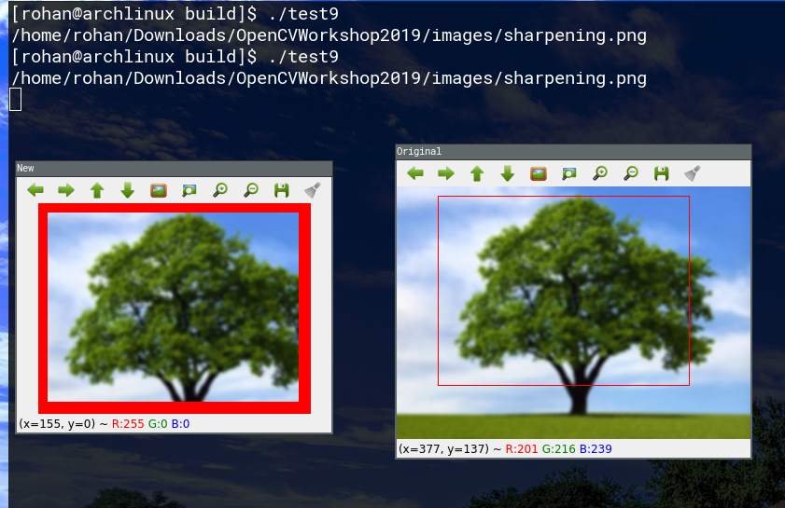

**Question 10:** Generate difference image from two grey images and apply binary thresholding on the difference image.

**Code:**

#include <opencv2/opencv.hpp>

#include <iostream>

#include <string>

cv::Mat diffImage;

int value = 127, max_value = 255;

void callback(int, void*)

{

cv::Mat img = diffImage.clone();

cv::threshold(img, img, value, max_value, cv::ThresholdTypes::THRESH_BINARY);

cv::imshow("Thresholded", img);

}

int main()

{

std::string image1, image2; std::cin >> image1 >> image2;

cv::Mat backgroundImage = cv::imread(image1);

cv::Mat currentImage = cv::imread(image2);

cv::resize(backgroundImage, backgroundImage, currentImage.size());

cv::absdiff(backgroundImage, currentImage, diffImage);

cv::imshow("Diff", diffImage);

cv::cvtColor(diffImage, diffImage, cv::COLOR_BGR2GRAY);

cv::namedWindow("Thresholded");

cv::createTrackbar("Threshold", "Thresholded", &value, max_value, callback);

callback(value, 0);

cv::waitKey();

}

**Output:**

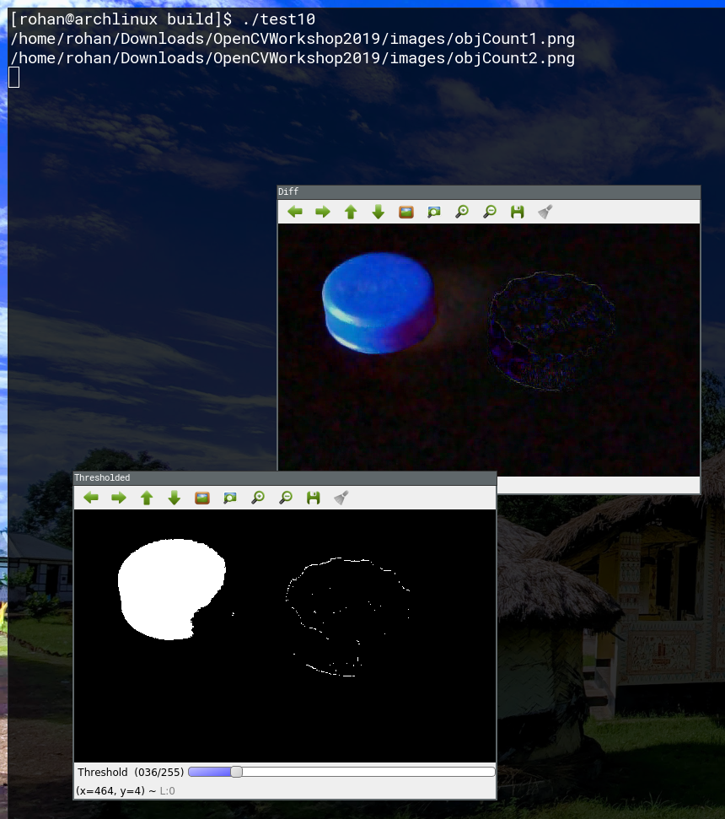

**Question 11:** Overlay a logo-image on another image at a given location.

**Code:**

#include <opencv2/opencv.hpp>

#include <iostream>

#include <string>

int main()

{

std::string f1, f2; std::cin >> f1 >> f2;

cv::Mat img = cv::imread(f1);

cv::Mat logo = cv::imread(f2);

cv::Vec2b x(0, 0);

for(int i = 0; i < logo.rows; i++)

for(int j = 0; j < logo.cols; j++)

img.at<cv::Vec3b>(i + x[0], j + x[1]) = img.at<cv::Vec3b>(i + x[0], j + x[1]) * 0.5 + logo.at<cv::Vec3b>(i, j) * 0.5;

cv::imshow("Overlay", img);

cv::waitKey();

}

**Output:**

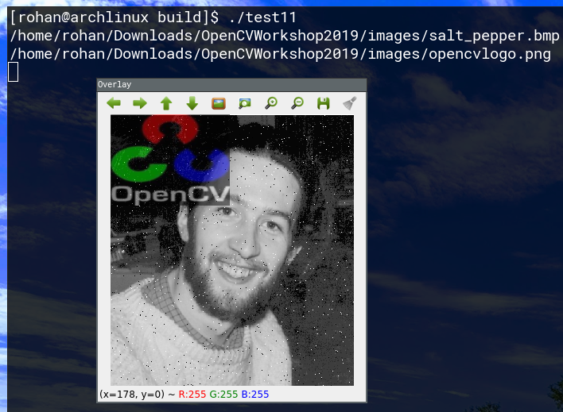

**Question 12:** Perform dilation and erosion on a binary image.

**Code:**

#include <opencv2/opencv.hpp>

#include <iostream>

#include <string>

int main()

{

std::string filename; std::cin >> filename;

cv::Mat img = cv::imread(filename);

cv::Mat kernel = cv::Mat::ones(cv::Size(5, 5), CV_8U);

cv::Mat erode, dilate;

cv::erode(img, erode, kernel, cv::Point(), 10);

cv::imshow("eroded", erode);

cv::dilate(img, dilate, kernel, cv::Point(), 10);

cv::imshow("dilated", dilate);

cv::waitKey();

}

**Output:**

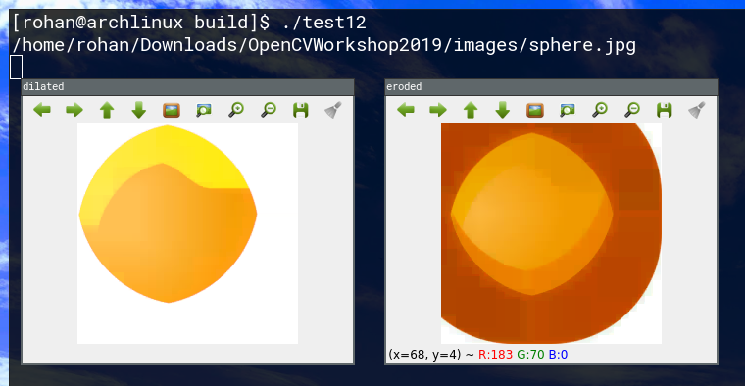

**Question 13:** Apply box and median filtering to smooth a grey image.

**Code:**

#include <opencv2/opencv.hpp>

#include <iostream>

#include <string>

int main()

{

std::string filename; std::cin >> filename;

cv::Mat img = cv::imread(filename);

cv::Mat blur, medianBlur;

cv::blur(img, blur, cv::Size(5, 5));

cv::medianBlur(img, medianBlur, 15);

cv::imshow("Blur", blur);

cv::imshow("Median Blur", medianBlur);

cv::waitKey();

}

**Output:**

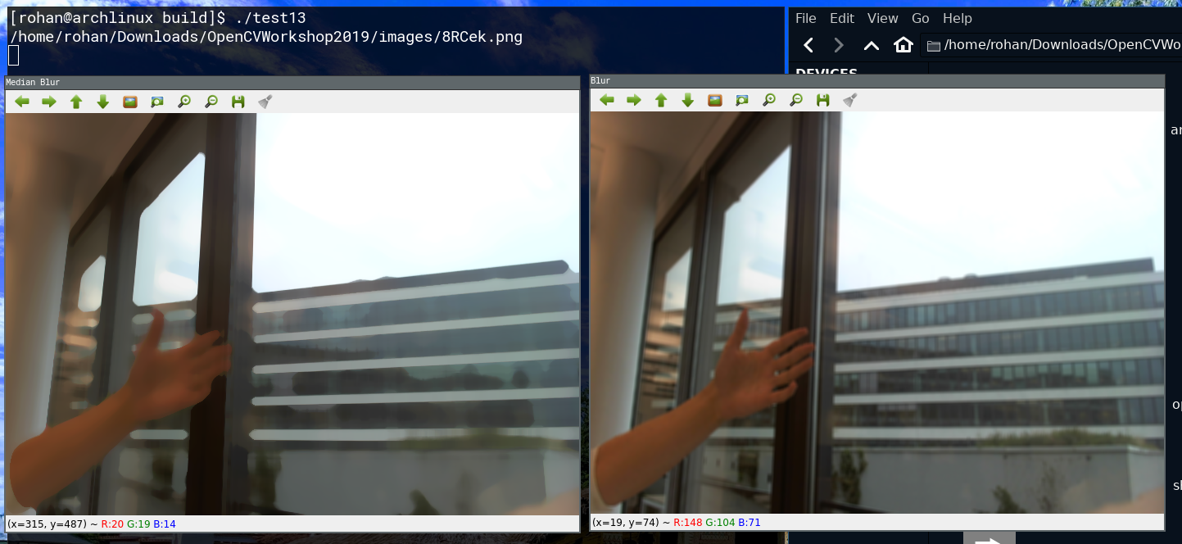

**Question 14:** Sharpen a grey image using Laplacian filter.

**Code:**

#include <iostream>

#include <string>

#include <opencv2/opencv.hpp>

int main()

{

std::string filename; std::cin >> filename;

cv::Mat img = cv::imread(filename);

cv::Mat lap_img;

cv::Laplacian(img, lap_img, CV_16S, 3);

cv::convertScaleAbs(lap_img, lap_img);

cv::imshow("Laplace", lap_img);

cv::waitKey();

}

**Output:**

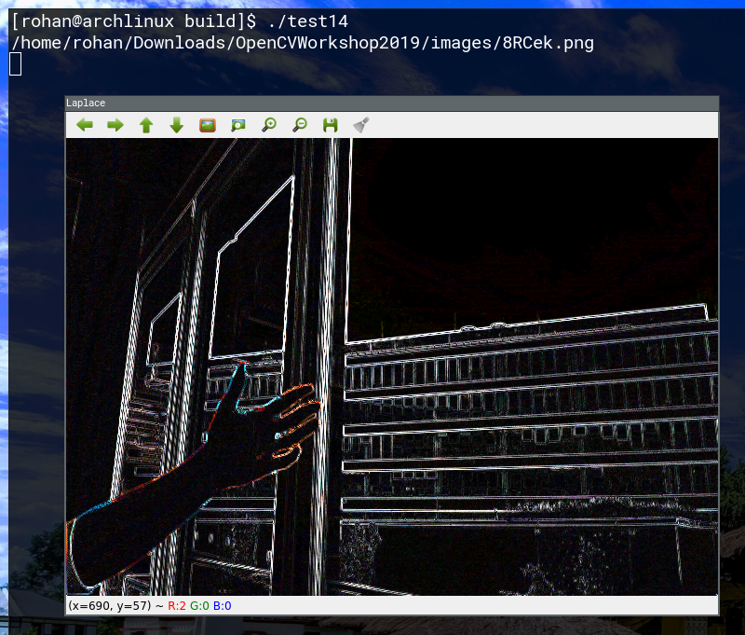

**Question 15:** Extract edge of a grey image using Sobel filter.

**Code:**

#include <iostream>

#include <string>

#include <opencv2/opencv.hpp>

int main()

{

std::string filename; std::cin >> filename;

cv::Mat img = cv::imread(filename);

cv::Mat sobl_img;

cv::Sobel(img, sobl_img, CV_16S, 0, 1, 3);

cv::convertScaleAbs(sobl_img, sobl_img);

cv::imshow("Sobel", sobl_img);

cv::waitKey();

}

**Output:**

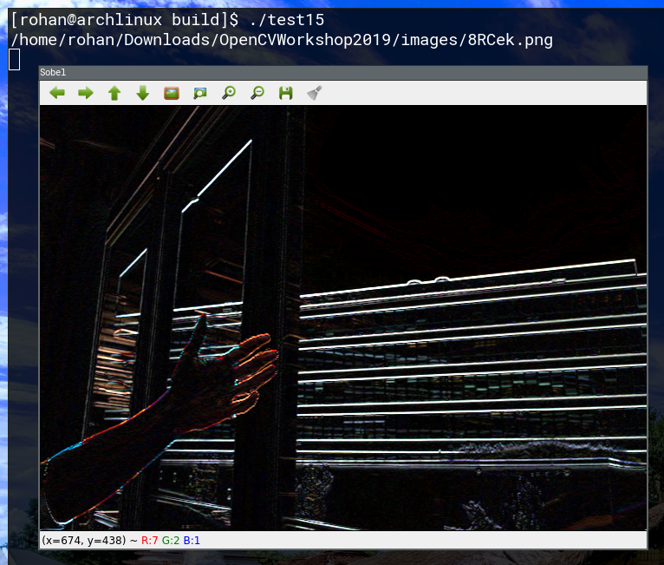

**Question 16:** Extract green-intensity dominant pixels from a colour image based on a) RGB and b) HSV.

**Code:**

#include <iostream>

#include <string>

#include <opencv2/opencv.hpp>

int main()

{

std::string filename; std::cin >> filename;

cv::Mat img = cv::imread(filename);

cv::Mat img_rgb, img_hsv;

cv::cvtColor(img, img_rgb, cv::COLOR_BGR2RGB);

cv::cvtColor(img, img_hsv, cv::COLOR_BGR2HSV);

cv::Mat ans;

cv::inRange(img_rgb, cv::Scalar(30, 66, 3), cv::Scalar(178, 232, 137), ans);

cv::imshow("threshold_rgb", ans);

cv::inRange(img_hsv, cv::Scalar(30, 66, 3), cv::Scalar(178, 232, 137), ans);

cv::imshow("threshold_hsv", ans);

cv::waitKey();

}

**Output:**

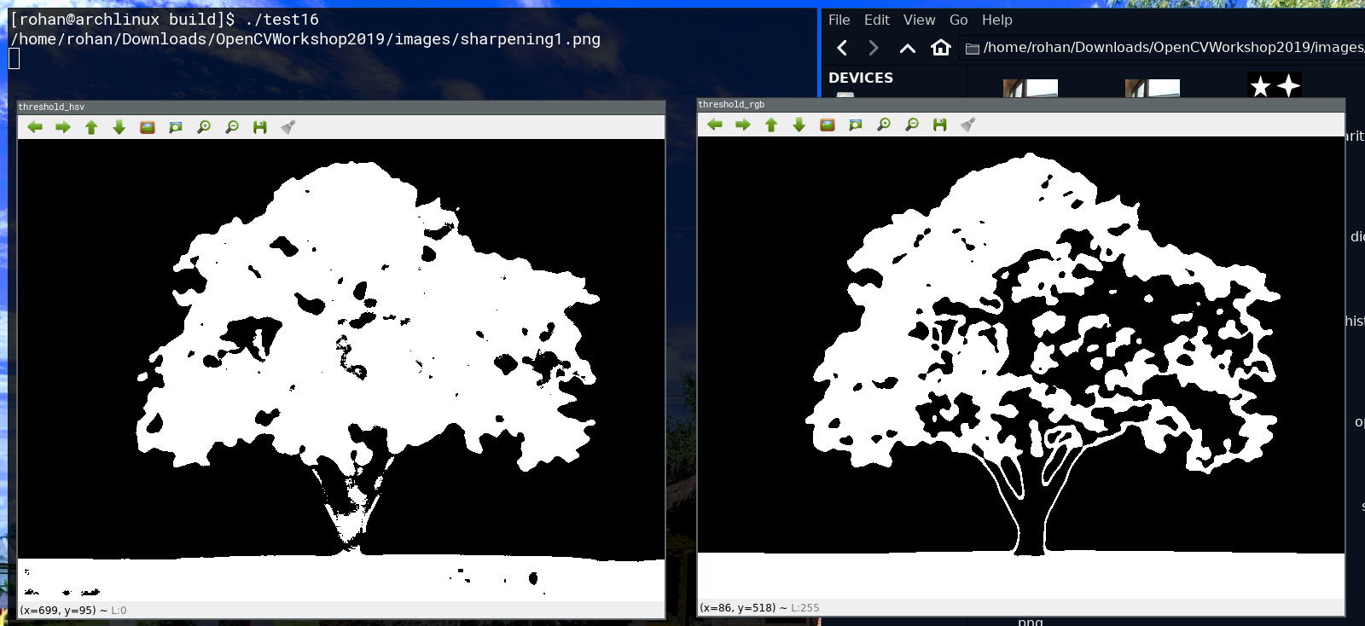

**Question 17:** Apply Gaussian Low and High pass filtering on a grey image.

**Code:**

#include <iostream>

#include <string>

#include <opencv2/opencv.hpp>

int main()

{

std::string filename; std::cin >> filename;

cv::Mat img = cv::imread(filename);

cv::Mat img_blur;

cv::GaussianBlur(img, img_blur, cv::Size(31, 31), 0);

cv::Mat img_hpf = img - img_blur;

img_hpf = img_hpf + cv::Scalar(127, 127, 127);

cv::imshow("High Pass Filter", img_hpf);

cv::imshow("Low Pass Filter", img_blur);

cv::waitKey();

}

**Output:**

